CRUD Operations

Objective
The objective of this submission is to perform Create, Read, Update, and Delete (CRUD) operations on the Seller and Inventory tables in the ShopEaseDB database.

Create Operation
A new seller is added to the Seller table.
INSERT INTO Seller
(Seller_Name, Phone, Email, Address)
VALUES
('Green Basket Traders', '9876543224', 'greenbasket@gmail.com', 'Salem');
SELECT * FROM Seller;
Result:
A new seller record was successfully inserted.
Result:
A new seller record was successfully inserted into the ShopEaseDB database.
Read Operation
The inventory records are displayed using:
The current inventory records are displayed using:
Result:
The seller and inventory records were successfully displayed.
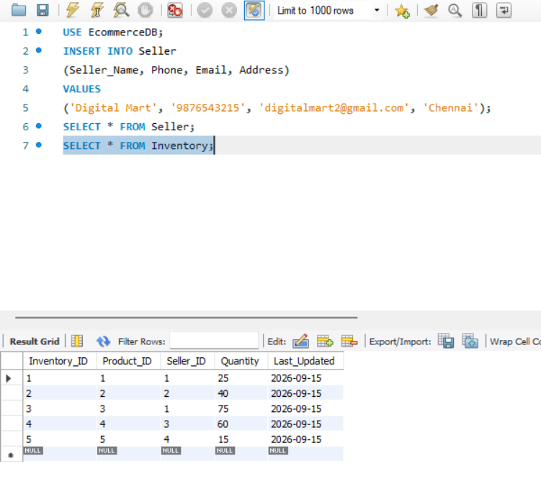
The seller and inventory records were successfully displayed.
Update Operation
The inventory quantity of a product is increased by 15.
SET SQL_SAFE_UPDATES = 0;
UPDATE Inventory
SET Quantity = Quantity + 15
WHERE Inventory_ID = 2;
To verify the updated record:
SELECT * FROM Inventory
WHERE Inventory_ID = 2;
Result:
The inventory quantity was successfully updated.
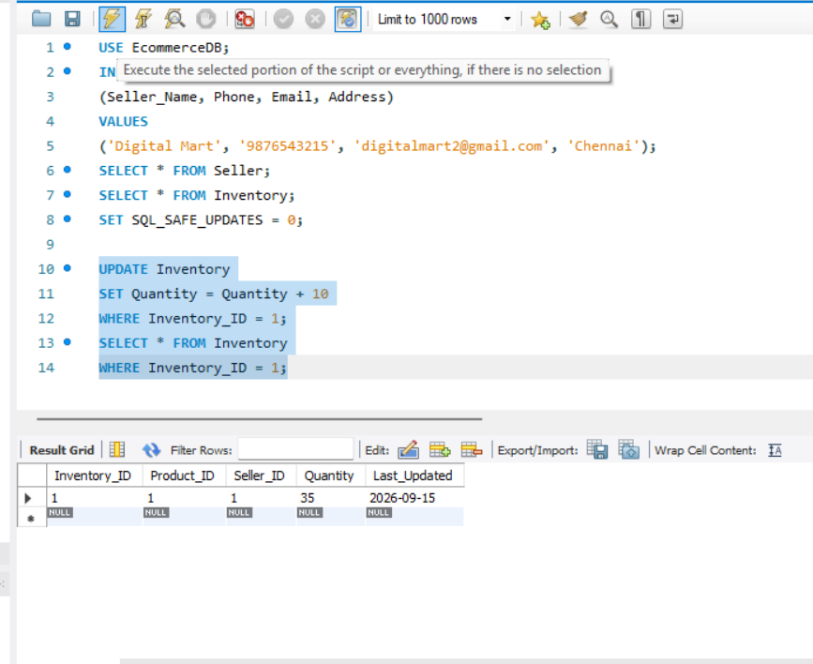
The inventory quantity was successfully updated by 15 units.

Delete Operation – Updated
An inventory record is removed from the Inventory table.
DELETE FROM Inventory
WHERE Inventory_ID = 5;
To verify the deletion:
SELECT * FROM Inventory;

Result:
The selected inventory record was successfully deleted.
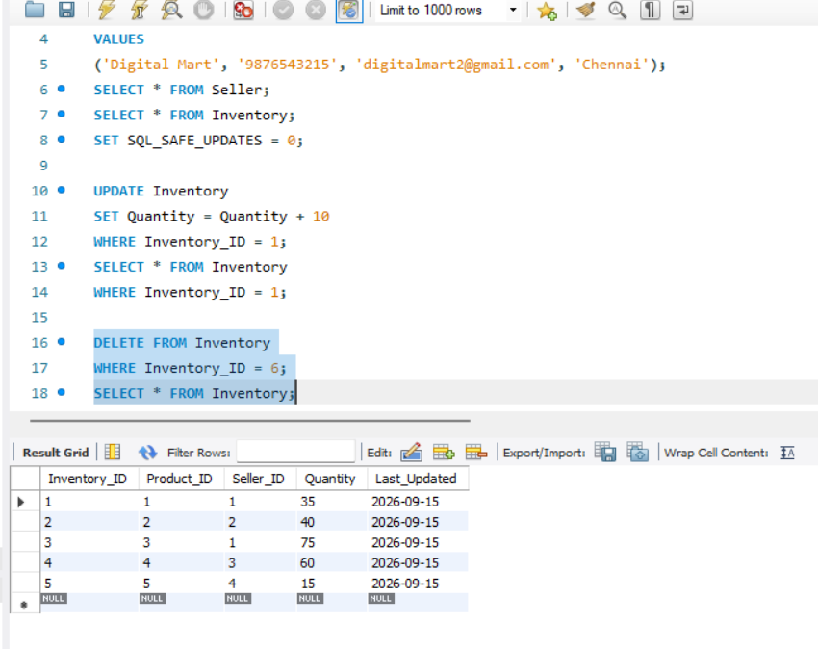

Result
The CRUD operations were successfully performed on the Seller and Inventory tables. A seller was inserted, records were displayed, an inventory quantity was updated, and an inventory record was deleted successfully.

